FACULTY EVALUATION
Programme Name: Sisters’ Blended Value Program (Sbvp)Social Entrepreneurship Development Program (SEDP) Advance Module 3 Zambia (26th January 2026 - 30th January 2026)
Session: Operations and Efficiency
Faculty Name: Felix Mogesa Motari
No. of Respondents: 13
No. of Participants: 13
Evaluation Parameter | (%) Individual Score | (%) Programme Average
Punctuality (Commencement and Completion of Sessions) | 95 | 95
How well do you understand the core concepts presented? | 92 | 91
Rate your confidence in applying the new skills learnt | 93 | 92
Degree of Faculty preparedness for the sessions | 92 | 95
Content and methodology of the program | 93 | 96
Quality of class and group discussions | 93 | 95
The information presented in the course is relevant to my work (ministry) | 92 | 92
Average scores | 93 | 94

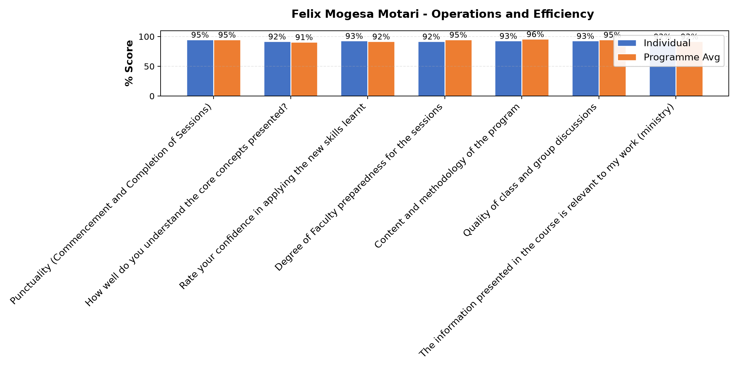

Comments & Feedback
- • Good lecture
- • It was great thanks, very effective to my project
- • Thanks
- • Well presented
- • Today was great thank you. We learnt how to identify operational efficiency and objectives in our enterprises. Things that we have not been doing well to improve as well things that we have done that need continuing. Just like yesterday we need to keep records in order to identify the demands as well to reach the capacity through developing strategies.
- • To see how transportation affects us in positive way as well in negative way due to challenges faced on the road network
- • I have learnt what TIMWOODS can do if we evaluate on our enterprise using this tool.
- • Mostly to keep records on all to help see where things have gone wrong in our enterprise.
- • Thanks for all the information given we need more time and practice for this session
- • keep it up 👍❤️
- • The content where very relevantant
- • Mr. Mogesa can do better in future
- • We need to have Todays this Topic
SUBMITTED THROUGH:
SBS Evaluation Automation System

